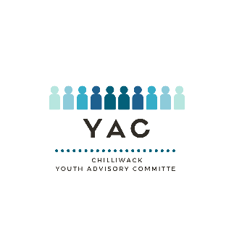
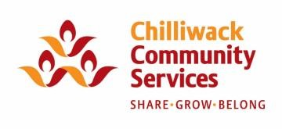
CHILLIWACK YOUTH ADVISORY COMMITTEE
APPLICATION DRAFT

Due Date: August 27th 2021
please note that the application will be provided both in paper and online form for submission
Name:
Pronouns:
Date of Birth:
School (if applicable):
Grade (if applicable):
Address:
Phone Number:
Email Address:

- What community and/or school groups are you currently involved in?

- What life experiences have inspired you towards leadership and advocacy for youth in Chilliwack?

- Each advisor will have an individual project as a chance to advocate for the youth in the City of Chilliwack, what subjects would be your top 3 priorities?

Are you able to commit an average of 2-3 hours a week to this program?
Comment:
Are you available for an in-person interview between August 30th and September 3rd 2021?
Comment:
CHILLIWACK YOUTH ADVISORY COMMITTEE
APPLICATION DRAFT

With the additional funding received from the City of Chilliwack for Chilliwack Community
Services’ (CCS) Youth Recreation Program, CCS along with the Chilliwack Child and Youth Committee (CYC), inclusive of many local agencies, will implement a Youth advisory Committee (YAC) to enhance existing youth services provided to ages 14 to 18 in Chilliwack.
What is YAC?
- The committee will consist of 12 to 16 leaders who will represent the diverse youth population of Chilliwack.
- The Youth on the committee will be a representation of youth voices whose purpose is to advocate on behalf of youth through identifying, improving, and increasing services and programs for youth in Chilliwack.
- YAC will be involved in volunteer opportunities in the community. They will plan, develop, implement, and evaluate large and small community-wide events focused on bringing youth together to connect, learn and grow.
- YAC will work with the Mayor and City Council to ensure youth voices are being incorporated into city-wide initiatives.
- YAC will support the coordination, awareness, and communication of existing and new youth resources and services in our community to all youth.
Canvassing for the youth candidates for YAC is fully inclusive. The youth will be encouraged to apply by August 27, 2020. Candidates selected will be interviewed the week of August 30th and September 2nd.
YAC will meet every Monday starting in September 13th 2021. Meetings will alternate between psycho-educational lesson or conversation, and a more practical planning and implementation activity. Attendance to these meetings will be considered mandatory for participants in the program. Participants will be offered other opportunities to represent the program on a noncompulsory basis.
External goals include participation in Youth Week 2020, and developing increased awareness around youth concerns such as mental health. Internally, youth will be asked to develop a personal project to implement within their own communities in an effort to use their webbed capacity to directly serve and represent the largest possible number of youth in Chilliwack. Completing these personal projects on your individual time with support from YAC will be required as a YAC member.
YAC is looking for youth who ages 14 to 18 who are interested in advocating for other youth in Chilliwack, and who are passionate about social issues. Youth from a wide variety of backgrounds and experiences will be considered. Youth will be expected to attend weekly meetings and communicate effectively with the YAC Coordinator and others on the team.
If you have questions or comments, please contact Haley Hodgkinson via call or text (604) 702-8292 or send an email to hodgkinsonh@comserv.bc.ca.

